LAB EXERCISE 2

ENCRYPTION – CRYPTO 101 IN TRYHACKME PLATFORM

AIM
To understand the fundamentals of cryptography by performing hands-on exercises in the Crypto 101 room on the TryHackMe platform, including encoding, encryption, classical ciphers, hashing, and cryptographic concepts.

TOOLS / PLATFORM REQUIRED
Web Browser (Chrome / Firefox)
Internet Connection
TryHackMe Account (Free)
TryHackMe AttackBox or Local Linux Machine

PROCEDURE

STEP 1: LOGIN TO TRYHACKME
Open a web browser

Go to:
https://tryhackme.com
Login using your registered credentials

STEP 2: OPEN CRYPTO 101 ROOM
Use the search bar and type Crypto 101
Click on the room named Crypto 101
Click Join Room

STEP 3: START ATTACKBOX
Click Start AttackBox / Start Machine
Wait until the virtual environment loads

STEP 4: PERFORM CRYPTOGRAPHY TASKS
4.1 ENCODING & DECODING:
(a) BASE64 ENCODING / DECODING

Purpose:
Base64 is an encoding technique used to convert binary data into readable ASCII format.
Decode Base64

Command:

echo "Q3J5cHRvZ3JhcGh5" | base64 -d

Output:

Cryptography
Encode Base64
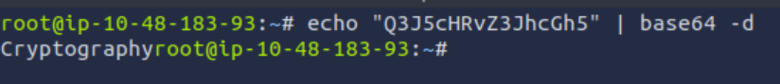

Command:

echo "cryptography" | base64

Output:
Y3J5cHRvZ3JhcGh5Cg==

(b) HEXADECIMAL CONVERSION

Purpose:
Hexadecimal is a base-16 encoding system widely used in computing.

Hex to Text
echo 48656c6c6f | xxd -r -p

Output:
Hello

Text to Hex
echo "Hello" | xxd -p
Output:

4.2 CLASSICAL CIPHERS
(a) CAESAR CIPHER

Purpose:
Caesar cipher shifts each letter by a fixed number.

Command (Shift = 3):

echo "KHOOR" | tr 'A-Z' 'X-ZA-W'

Output:
HELLO
(b) SHIFT-BASED ENCRYPTION

Purpose:
A generalized Caesar cipher using different shift values.

Method:

Try different shift values
Identify readable plaintext

Example Result:

Shift 1 → Incorrect
Shift 3 → Meaningful text → Correct
Output:

(c) PLAYFAIR CIPHER

Purpose:
Playfair cipher encrypts pairs of letters using a key matrix.

STEP 1: CREATE FILE
nano playfair_cipher.py
STEP 2: PLAYFAIR CIPHER CODE
import argparse
import re

def normalize(text):
text = re.sub(r'[^A-Za-z]', '', text).upper()
return text.replace('J', 'I')

def build_matrix(key):
key = normalize(key)
alphabet = "ABCDEFGHIKLMNOPQRSTUVWXYZ"
seen = []
for c in key + alphabet:
if c not in seen:
seen.append(c)
matrix = [seen[i:i+5] for i in range(0, 25, 5)]
pos = {matrix[r][c]: (r, c) for r in range(5) for c in range(5)}
return matrix, pos

def digraphs(text):
text = normalize(text)
i = 0
pairs = []
while i < len(text):
a = text[i]
b = text[i+1] if i+1 < len(text) else 'X'
if a == b:
pairs.append((a, 'X'))
i += 1
else:
pairs.append((a, b))
i += 2
return pairs

def encrypt(text, key):
matrix, pos = build_matrix(key)
result = ""
for a, b in digraphs(text):
ra, ca = pos[a]
rb, cb = pos[b]
if ra == rb:
result += matrix[ra][(ca+1)%5] + matrix[rb][(cb+1)%5]
elif ca == cb:
result += matrix[(ra+1)%5][ca] + matrix[(rb+1)%5][cb]
else:
result += matrix[ra][cb] + matrix[rb][ca]
return result

def decrypt(text, key):
matrix, pos = build_matrix(key)
result = ""
for i in range(0, len(text), 2):
a, b = text[i], text[i+1]
ra, ca = pos[a]
rb, cb = pos[b]
if ra == rb:
result += matrix[ra][(ca-1)%5] + matrix[rb][(cb-1)%5]
elif ca == cb:
result += matrix[(ra-1)%5][ca] + matrix[(rb-1)%5][cb]
else:
result += matrix[ra][cb] + matrix[rb][ca]
return result

if __name__ == "__main__":
parser = argparse.ArgumentParser()
parser.add_argument("mode", choices=["enc", "dec"])
parser.add_argument("-k", "--key", required=True)
parser.add_argument("-t", "--text", required=True)
args = parser.parse_args()

if args.mode == "enc":
print(encrypt(args.text, args.key))
else:
print(decrypt(args.text, args.key))

STEP 3: SAVE FILE
Press CTRL + X
Press Y → Enter

STEP 4: EXECUTE PLAYFAIR CIPHER

Encryption

python3 playfair_cipher.py enc -k "MONARCHY" -t "hide the gold"

Output:
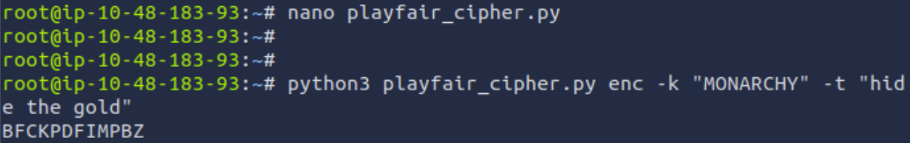

Decryption

python3 playfair_cipher.py dec -k "MONARCHY" -t "BMNDZBXDKYBEJVDMUIXMMOUVIF"
nam

(d) VIGENÈRE CIPHER

Instruction:
Follow the same steps as Playfair and create vigenerecipher.py.
Use Python logic for shifting characters using a repeating key.
CODE:
import argparse

def generate_key(text, key):
key = key.upper()
key_new = ""
j = 0
for i in range(len(text)):
if text[i].isalpha():
key_new += key[j % len(key)]
j += 1
else:
key_new += text[i]
return key_new

def encrypt(text, key):
result = ""
key = generate_key(text, key)

for i in range(len(text)):
if text[i].isupper():
result += chr((ord(text[i]) + ord(key[i]) - 2*ord('A')) % 26 + ord('A'))
elif text[i].islower():
result += chr((ord(text[i]) + ord(key[i]) - 2*ord('a')) % 26 + ord('a'))
else:
result += text[i]
return result

def decrypt(text, key):
result = ""
key = generate_key(text, key)

for i in range(len(text)):
if text[i].isupper():
result += chr((ord(text[i]) - ord(key[i]) + 26) % 26 + ord('A'))
elif text[i].islower():
result += chr((ord(text[i]) - ord(key[i]) + 26) % 26 + ord('a'))
else:
result += text[i]
return result

if __name__ == "__main__":
parser = argparse.ArgumentParser(description="Vigenere Cipher")
parser.add_argument("mode", choices=["enc", "dec"], help="enc = encrypt, dec = decrypt")
parser.add_argument("-k", "--key", required=True, help="Cipher key")
parser.add_argument("-t", "--text", required=True, help="Text")

args = parser.parse_args()

if args.mode == "enc":
print(encrypt(args.text, args.key))
else:
print(decrypt(args.text, args.key))
Command:
python3 vigenerescipher.py enc -k "KEY" -t "HELLO WORLD"
Output:

4.3 HASHING
(a) HASH ALGORITHM IDENTIFICATION
Hash Type Length
MD5 32 characters
SHA-1 40 characters
SHA-256 64 characters
(b) GENERATING HASHES
echo -n "hello" | md5sum
echo -n "hello" | sha1sum
echo -n "hello" | sha256sum
4.4 ENCRYPTION CONCEPTS
(a) ENCRYPTION vs HASHING
Encryption Hashing
Reversible Irreversible
Uses keys No keys
Secure communication Password storage

(b) SYMMETRIC vs ASYMMETRIC
Symmetric Asymmetric
One key Two keys
Faster Slower

STEP 5: VERIFY COMPLETION
Ensure all room tasks are marked Completed
Observe the success message in the Crypto 101 room

OUTPUT:
Successfully decoded Base64 and Hex values
Successfully executed Caesar and Playfair ciphers
Successfully generated and identified hashes
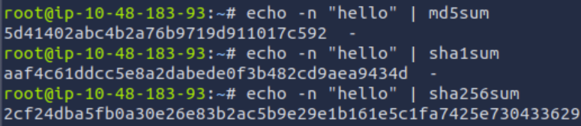

RESULT:

Thus, the Crypto 101 experiment was successfully completed on the TryHackMe platform.
This experiment provided hands-on understanding of encoding, encryption, classical ciphers, hashing, and cryptographic fundamentals.

